FACULTY DETAILS (FOR NEW WEBSITE)
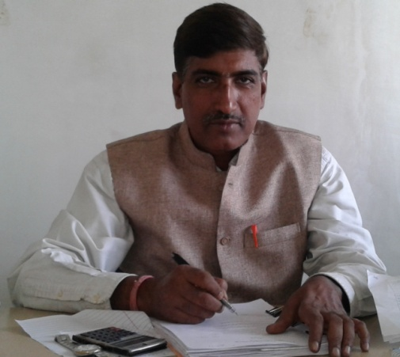 | Name | MANINDRA NATH MISHRA
 | Designation | LECTURER
 | Experience | - 20 Years Experience in Civil construction work.  - 3 years & 7 months (Still Continuing) experience in Academic Field.
 | Qualification | B.Sc . Engg. (Civil ) In 1993 from NIT Jamshedpur
 | Area of Interest | Geo tech Engg. , Concrete Structure , Building Materials and Construction.
 | Field of Research | NA
 | e-mail | hodce@bacet.ac.in
 | Member of Professional Body | NA
 | No of PhD Guided | NA
 | Publication (Recent First) | NA

FACULTY DETAILS (FOR NEW WEBSITE)
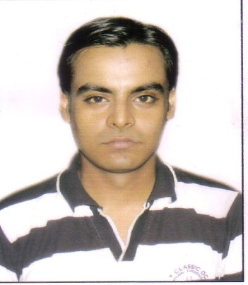 | Name | SUMIT KUMAR BANERJEE
 | Designation | ASSISTANT PROFESSOR
 | Experience | 1.5 YEARS
 | Qualification | M.Tech in Water Resources Engineering
 | Area of Interest | Water Resources Engineering, Open Channel Flow, Hydraulics, Hydrology, Environmental Engineering, Fluid Mechanics
 | Field of Research | Sediment Transports in Open Channel Flow
 | e-mail | sumit.banerjee51@gmail.com
 | Member of Professional Body | NA
 | No of PhD Guided | NA
 | Publication (Recent First) | NA

FACULTY DETAILS (FOR NEW WEBSITE)
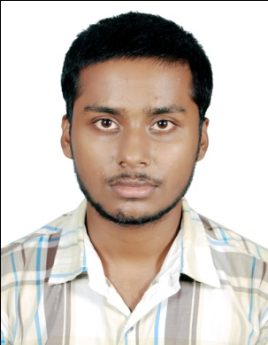 | Name | SHANTI SWAROOP
 | Designation | ASST. PROFESSOR
 | Experience | - Industrial Experience: 1 YEAR 6 MONTHS  - Teaching Experience: 0 YEAR 5 MONTHS
 | Qualification | M.TECH IN TRANSPORTATION ENGINEERING
 | Area of Interest | TRANSPORTATION ENGINEERING
 | Field of Research | FLEXIBLE PAVEMENT
 | e-mail | ISHANTISWAROOP@GMAIL.COM
 | Member of Professional Body | NA
 | No of PhD Guided | NA
 | Publication (Recent First) | NA

FACULTY DETAILS (FOR NEW WEBSITE)
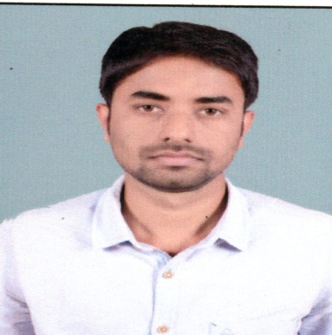 | Name | MANIRANJAN KUMAR
 | Designation | ASSISTANT PROFESSOR
 | Experience | 01
 | Qualification | M.Tech
 | Area of Interest | Fluid Mechanics, Water resources Engineering, Environmental Engineering, Geotech,
 | Field of Research | Water Resources Engineering
 | e-mail | Singhmaniranjan4@gmail.com
 | Member of Professional Body
 | No of PhD Guided
 | Publication (Recent First)

FACULTY DETAILS (FOR NEW WEBSITE)
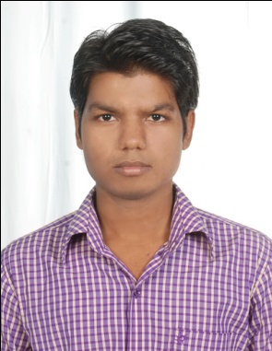 | Name | MUKESH KUMAR
 | Designation | LECTURER
 | Experience | 2.5 years
 | Qualification | B.TECH in CIVIL ENGINEERING
 | Area of Interest | SURVEYING, REMOTE SENSING & GIS.
 | Field of Research | NA
 | e-mail | Mukesh.jitm786@gmail.com
 | Member of Professional Body | NA
 | No of PhD Guided | NA
 | Publication (Recent First) | NA

FACULTY DETAILS (FOR NEW WEBSITE)
 | Name | SOUGATA MAHATO
 | Designation | TEACHING ASSISTANT
 | Experience | 1 YEAR
 | Qualification | B.Tech
 | Area of Interest | Bridge Engineering, Environmental Engineering,  Geo-Tech Engineering, Traffic Engineering
 | Field of Research | NA
 | e-mail | nandusougata@gmail.com
 | Member of Professional Body | NA
 | No of PhD Guided | NA
 | Publication (Recent First) | NA

