FACULTY DETAILS (FOR NEW WEBSITE)
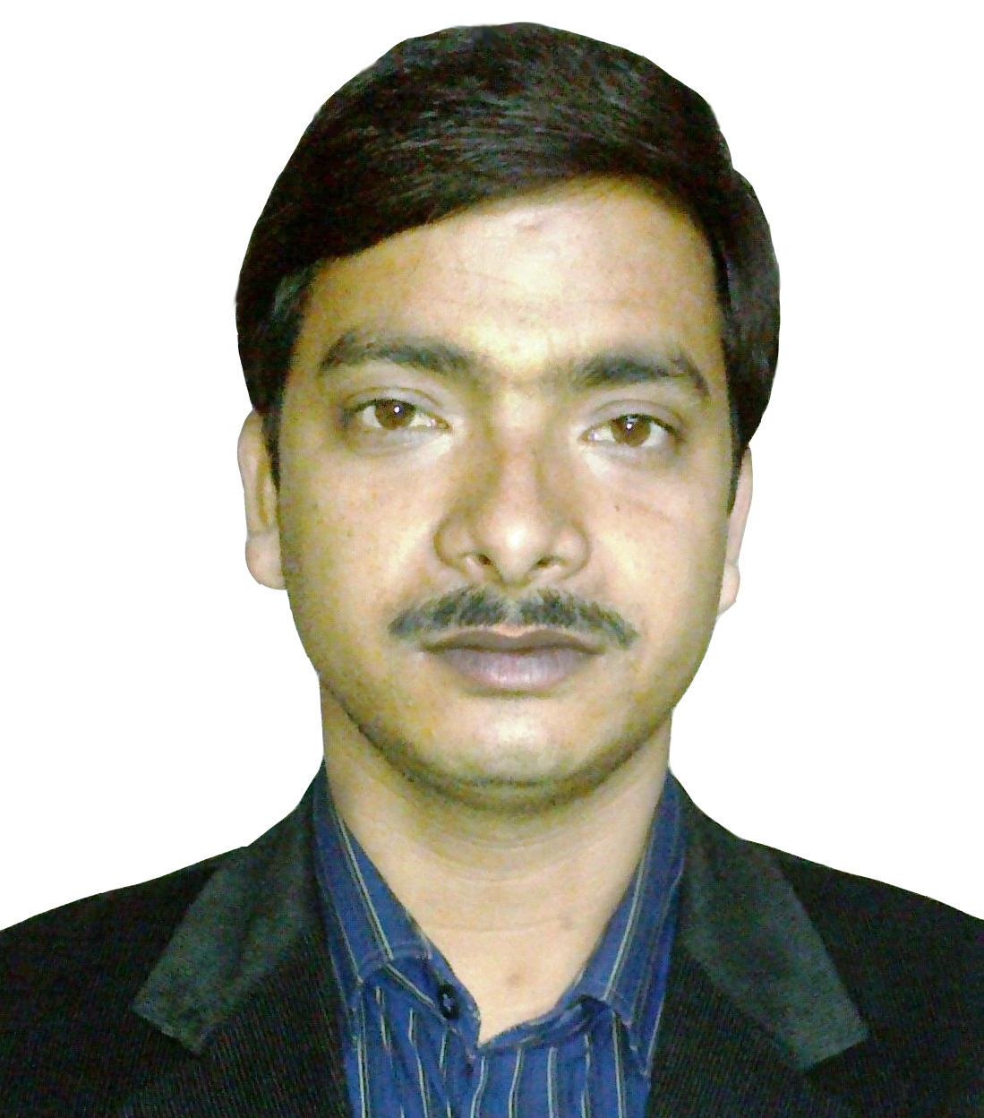 | Name | MURARI KRISHNA SAHA
 | Designation | ASISSTANT PROFESSSOR
 | Experience | 7 YEAR
 | Qualification | M.TECH
 | Area of Interest | NETWOR SECURITY, CLOUD COMPUTING
 | Field of Research | NETWOR SECURITY, CLOUD COMPUTING
 | e-mail | Murari.krishna007@gmail.com
 | Member of Professional Body | International Association of Engineers (IAENG).  International Association of Computer Science and Information Technology (IACSIT).  International Journal of Cloud Computing  and Services Science (IJ-CLOSER).
 | No of PhD Guided | 0
 | Publication (Recent First) | Rajesh Bose, Murari Krishna Saha, Debabrata Sarddar, “Fog computing Made Easy With the Help of Citrix and Billboard Manager” International Journal of Computer Applications. ISBN : 973-93-80887-83-2, Volume 121, 7 November 2015.

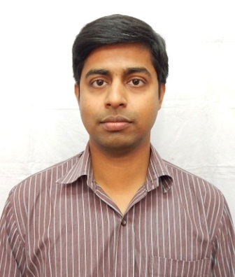 | Name | Kunal Kundu
 | Designation | Assistant Professor, HOD
 | Experience | 7 Years
 | Qualification | M. Tech.
 | Area of Interest | Analysis & Design of Algorithms, Compiler Design, Data Structures, C, C++, Python
 | Field of Research | Machine Learning
 | e-mail | kunal.vlsi08@gmail.com
 | Member of Professional Body
 | Publication (Recent First)

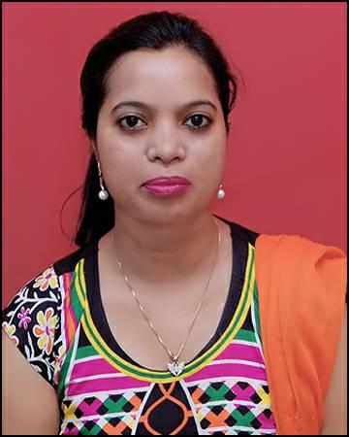 | Name | Ms. Arti kumari
 | Designation | Assistant professor
 | Experience | 7 Years
 | Qualification | M.Tech
 | Area of Interest | Internet Fundamental and Application,Web Technology,Computer Network,Operating System,Database Management System,
 | Field of Research | Information Security
 | e-mail | artikm99@gmail.com
 | Member of Professional Body | NA
 | No of PhD Guided | NA
 | Publication (Recent First) | NA

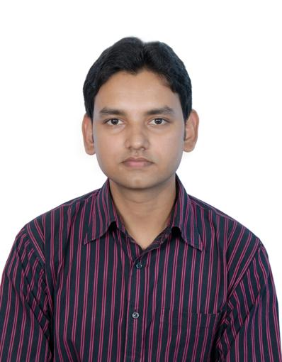 | Name | Ravi Bhushan Thakur
 | Designation | Assistant Professor
 | Experience | 4 Years
 | Qualification | M. Tech.
 | Area of Interest | Computer Architecture, RDBMS, Pattern Recognition, Data Mining
 | Field of Research | Data Mining
 | e-mail | Rbthakur18@gmail.com
 | Member of Professional Body
 | No of PhD Guided
 | Publication (Recent First)

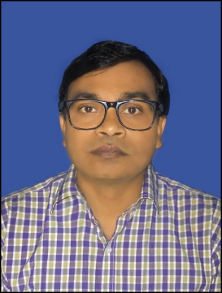 | Name | AMIT KUMAR
 | Designation | Assistant Professor
 | Experience | 07 Years in Teaching, 03 Years in Research
 | Qualification | M.Tech (CSE), PhD (Pursuing)
 | Area of Interest | Automata, Algorithm Design, Database Mgt. System, Computer Graphics, Software Engineering, Object Oriented Programming.
 | Field of Research | Data Mining, Soft Computing
 | e-mail | amit1022@gmail.com
 | Member of Professional Body | - Computer Science Teacher Association (CSTA) Member  ID: 7792505.  - Bioinformatics Organization
 | No of PhD Guided
 | Publication (Recent First) | - Amit Kumar, Dr.B.K.Sarkar “Performance analysis of GA-based Iterative and Non-iterative Learning Approaches for Medical Domain Data Sets” International Journal on Intelligent Decision Technologies, IOS Press, (In Press), Scopus and ESCI Indexed, 2017.  - Amit Kumar, Dr.B.K.Sarkar “A Case Study on Machine Learning and Classification” International Journal of Information and Decision Science, Inderscience, Vol. 3, No. 2, 179-208, Scopus Indexed, 2017.  - Amit Kumar “Utility of Rough Set Theory in Real Life Problems”. Proceedings of IT FLOOR, A Journal Mapping Lanes of Information Technology, B.R.A. University, Muzafferpur, Bihar. Vol.-III, Dec, 2014, (ISSN 2277-9639).  - Amit Kumar, Santosh Kumar, Manoj Kumar “A Comparative Study of Cloud Computing Over Grid Computing”. VSRD International Journal Of Computer Science and Information Technology, Vol.-III, June, 2013 (e-ISSN:2231-2471,p-ISSN:2319-2224).  - Amit Kumar “Use of DNA computing in Arithmetic and Logic Operation”, IEDES International Conference 2009 at BRCM CET, Haryana.

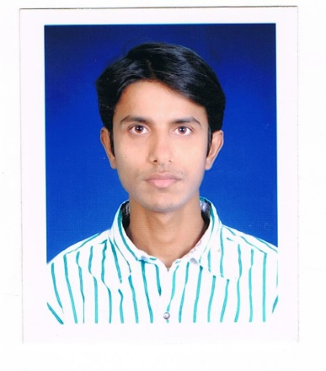 | Name | MANISH KUMAR
 | Designation | ASSISTANT PROFESSOR
 | Experience | 11 MONTHS
 | Qualification | Ph. D. (PURSUING)
 | Area of Interest | WIRELESS AND VEHICULAR AD HOC NETWORK, CRYPTOGRAPHY,BIO INSPIRED ALGORITHMS
 | Field of Research | SOFT COMPUTING AND BIOINFORMATICS
 | e-mail | MK9309@GMAIL.COM,MANISHKUMAR@CSE.ISM.AC.IN
 | Member of Professional Body | - International Association of Computer Science and Information Technology (IACSIT); Membership Id# 80348101.  - International Association of Online Engineering (IAOE); Membership Id #814.  - International Association of Engineers (IAENG); Membership Id #133259.  - International Association of Computer and Electronics Engineers (UACEE); Membership Id #SM1004695.  - The Society of Digital Information and Wireless Communications (SDIWC); Membership Id #2679.  - Member of Computer Science and Engineering Society, IIT(ISM) Dhanbad; Membership Id # 2014DR0110.
 | No of PhD Guided | NIL
 | Publication (Recent First) | Journals:  - Manish Kumar and Hari Om, “Protein Structure Prediction and Classification based on Biogeography Technique” Journal of Basic and Applied International. Vol.22 (3), 2017, pg: 99-104, ISSN 2395-3446.  - Manish Kumar and Hari Om “A Hill Climbing Approach for Residues Mapping in Protein Structures Alignment” International Journal of Engineering Technology & Engineering Sciences (Communicated)  - Manish Kumar and Hari Om, “An hybrid bio-inspired algorithm for alignment of multiple protein sequences,” Arabian Journal for Science and Engineering (AJSE) (Communicated to Springer (SCI indexed) journal)  - Manish Kumar “An enhanced algorithm for multiple sequence alignment of protein sequences using genetic algorithm” EXCLI Journal 2015;14: 1232-1255 – ISSN 1611-2156. (Science Citation Index -Expanded)  Conference:  - Manish Kumar and Hari Om “ A distributed network alignment based on protein-protein interaction”4th International Conference on harmony search, Soft Computing and Applications (ICHSA 2018) Feb 07-09, 2018 BML Munjal University, Gurgaon, India. (communicated)  - Manish Kumar and Hari Om “A Comparative Analysis of Soft Computing Techniques for Predicting Protein 3D Structure” 6th Int. Conf. on Recent Trends in Engineering, Science & Management (ICRTESM), 8 Jan, 2017, NITTTR, Chandigarh  - Manish Kumar and Hari Om, “Alignment of Multiple Randomly Generated Biological Sequences Through Enhanced Genetic Computation,” 5th Int. Conf. on Computing, communication and Sensor Network, pp. 61-64, Dec. 24-25, 2016, Kolkata. [Extended version submitted to Microsystems Technologies, Springer (SCI indexed) journal]  - Manish Kumar and Hari Om, “Prediction of Protein Tertiary Structure Using Cross Validation Technique,” 6th Int. Conf. on Science, Technology and Management, India International Centre, New Delhi, Dec.4, 2016.  - Manish Kumar and Hari Om “Soft Computing Techniques for Structural Classifications of Biological Sequences” 3rd Int. Conf. on Recent Trends and Advancements in Engineering and Technology (ICRTAET), Nov. 17-18, 2016 at Shri Mata Vaishno Devi University, Katra (J&K) .

