FACULTY DETAILS (FOR NEW WEBSITE)
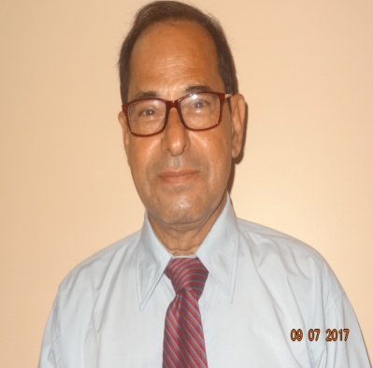 | Name | RANENDU KUMAR BHOL
 | Designation | Professor
 | Experience | 17 year teaching & 30 year Industry Experience
 | Qualification | B.Tech & M.Tech
 | Area of Interest | Machine Design
 | Field of Research | Design of Eccentric Gears
 | e-mail | hodme@bacet.ac.in
 | Member of Professional Body | Fellow Member of Institute of Engineer.
 | No of PhD Guided | NA
 | Publication (Recent First) | Paper published in PCRA, NPC and Journal.  Improvement Project published in Tata Motors Journal on Innovation.

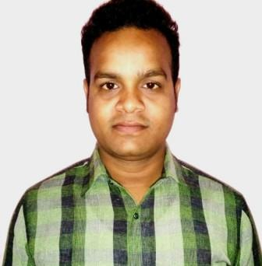 | Name | Chandan Gupta
 | Designation | Assistant Professor
 | Experience | 4 Years
 | Qualification | B.Tech,& M.Tech
 | Area of Interest | Thermal & Design Engineering
 | Field of Research | Thermal and Fluids Engineering
 | e-mail | Chandangupta2011@gmail.com
 | Member of Professional Body | NA
 | No of PhD Guided | NA
 | Publication (Recent First) | NA

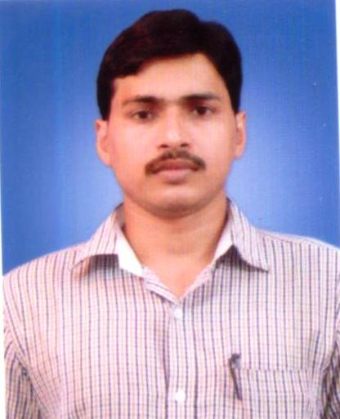 | Name | Santosh Chaubey
 | Designation | Assistant Professor
 | Experience | 5 Years
 | Qualification | B.Tech & M.Tech
 | Area of Interest | Production Engineering
 | Field of Research | Extrusion
 | e-mail | Santomech05@gmail.com
 | Member of Professional Body | NA
 | No of PhD Guided | NA
 | Publication (Recent First) | A Numerical Analysis of Extrusion of Square Section from Round Billet through Mathematically Contoured Die with Design of Die Profile  (Journal for Technology of plasticity,38,2013)

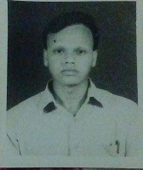 | Name | Kasif Ansari
 | Designation | Assistant Professor
 | Experience | 3 Years
 | Qualification | B.Tech,M.Tech
 | Area of Interest | Manufacturing
 | Field of Research | Welding
 | e-mail | k.ansari251@gmail.com
 | Member of Professional Body | NA
 | No of PhD Guided | NA
 | Publication (Recent First) | International Conference on Micro Plasma arc welding held on April 2014 at Delhi

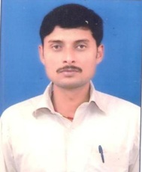 | Name | Manibhushan Kumar Dwivedi
 | Designation | Lecturer
 | Experience | 07 Years
 | Qualification | B.Tech & M.Sc.Engg. (Pursuing)
 | Area of Interest | Thermal & Design Engg.
 | Field of Research | N A
 | e-mail | manibhushandwivedi@gmail.com
 | Member of Professional Body | NA
 | No of PhD Guided | NA
 | Publication (Recent First) | NA

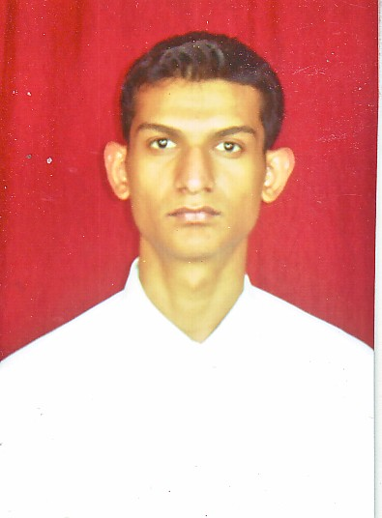 | Name | Gourav Prasad Sinha
 | Designation | Assistant Professor
 | Experience | 5 years
 | Qualification | M. E (Machine Design)
 | Area of Interest | Vibration , CAD
 | Field of Research | Vibration
 | e-mail | jsrgourav@gmail.com
 | Member of Professional Body | NA
 | No of PhD Guided | NA
 | Publication (Recent First) | Vibration Analysis of Hero Honda Vehicle

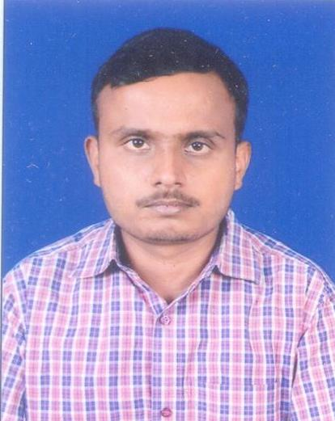. | Name | Hemant Kumar Jha
 | Designation | Assistant Professor
 | Experience | 4 Years
 | Qualification | B.Tech,& M.Tech
 | Area of Interest | Thermal & Design Engineering
 | Field of Research | Thermal and Fluids Engineering
 | e-mail | Hemantj310@gmail.com
 | Member of Professional Body | NA
 | No of PhD Guided | NA
 | Publication (Recent First) | NA

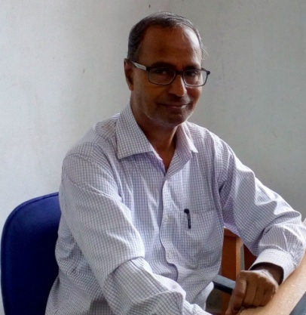 | Name | SURENDRA NARAIN MALLIK
 | Designation | PROFESSOR
 | Experience | 34 YEARS IN TATA STEEL & 21 years in teaching
 | Qualification | M. Sc. Engg (Hons)
 | Area of Interest | Automation ,I. C. Engines
 | Field of Research | Development of Steel Plant Equipment
 | e-mail | malliksn@yahoo.com
 | Member of Professional Body | MIIE
 | No of PhD Guided | Nil
 | Publication (Recent First) | S. N. Mallik, F. Mitra, “Automatic Coke Moisture Measurement System using Micro Oven”, Tata Steel Internal Publication (Patented)

